Gastric HPC
Module syllabus
There should be only one line per item as it has now two lines that indicate the same.
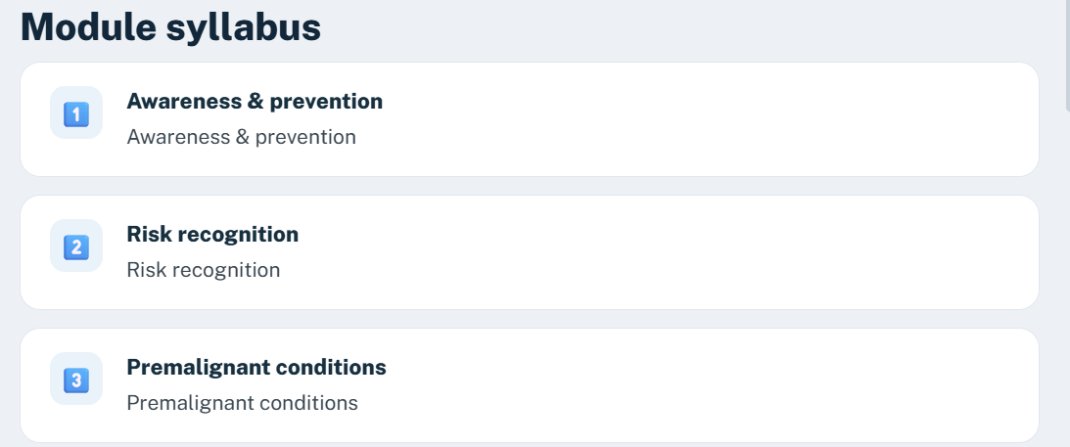
Session 1 Objectives
Random emojis. I updated the PPT to reflect appropriate ones.
What gastric cancer is
Images did not migrate. Make sure each image migrates to it’s respective item as there are 3 different.
How common it is worldwide
Graph did not migrate.
Gastric cancer in Rwanda
Graph did not migrate.
How gastric cancer develops
Images did not migrate. Make sure each image migrates to it’s respective item as there are 5 different. Note did not migrate either.
Conditions linked to higher risk
Images did not migrate. Make sure each image migrates to it’s respective item as there are 3 different.
Testing for H. pylori
Make sure H.pylori is in Italics.
Images populated in the incorrect order. I put then inside the square for accuracy.
Treating H. pylori
Make sure H.pylori is in Italics.
Images populated in the incorrect order. I put then inside the square for accuracy.
Stage and grade are different
Stage image missing
Meet Uwase 1
This slide should only contain the video. I removed all the content from the slide as it was guidance for the video creation.
Meet Uwase – Video
Video is not working
Risk factors
Should be bulleted content inside the box and not running text
Prevention and screening approaches vary
The box H. pylori screen-and-treat should be the first one and not the last one.
The recommendation in Rwanda
Boxes are in disorder. It should be 1. Risk-based approach, 2. H. Pylori prevention, and 3. Surveillance of premalignant conditions.
Uwase's story continues
Video is not working
Start with a focused history
Images did not migrate. Should be bulleted content inside the boxes and not running text.
The diagnostic pathway 1 and 2
Should be bulleted content inside the boxes and not running text.
Imaging, staging, and treatment planning
Should be bulleted content inside the boxes and not running text.
Treatment overview
The images are swapped. Surgery has radiotherapy image and radiotherapy has surgery image.
Adverse effects and care
All options are in the same order as they should be places. Can we shuffle?
Palliative care comic
It needs to be bigger

